This document:
1. Objectives.
Boosting is a general method for improving the accuracy of any given learning algorithm. One can use it to combine simple “rules” (or weak learner), each performing only slightly better than random guess, to form an arbitrarily good hypothesis. Viola and Jones employed Adaboost (an adaptive boosting method) for object detection and got good performance when applying to human face detection [1].
In this project, you are required to implement an Adaboost algorithm for frontal human face detection following Viola and Jones’ method, but cascade is not required.
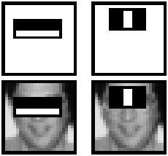
We provide a face dataset of 3,000 face images and a non-face dataset of 3,000 samples. Each image has 16 x 16 pixels.
The project includes the following steps.
(1) Construction of weak learners
Compute the value of each rectangle feature for each sample. Each feature corresponds to a weak learner. Determine the threshold between face samples and non-face samples for all the weak learners. Calculate the classification error for each weak learner and draw the best ten features (before boosting) as Figure 3 in [1].
(2) Boosting
Implement Adaboost algorithm following Table 1 in [1] to boost the weak learners you got in (1). Ranging the number of weak learners the algorithm selects (T in Table 1) from 2 to 200, plot the training errors (both false positives and false negatives). Draw the best ten features (after boosting) as Figure 3 in [1] and compare them with the features in (1).
(3) Cross validation
The above two steps deal with the whole dataset. Now randomly divide the dataset into 5 equal size non-overlapped subsets, use each set as testing set and the other four sets as training set, select T as 50, 100, 200, run the algorithm, record training and testing errors into a table.
2. Datasets
Face data: download from course webpage face.zip

Nonface data: download from course webpage non_face.zip

3. Advice
Start small. Write a program using only a small number of weak classifiers – like the two illustrated above. Train and test the program on a small set of face and non-face images. At every stage, check to make sure that your results make intuitive sense. For example, see if your program selects the same first two features that Viola found (see above).
Be very careful about how your program scales with the number of weak classifiers and the number of face/non-face images. (This will depend on the details of how you write the code and the type of computer you are using). If your program scales badly, then only use a limited number of weak classifiers and a small number of faces/non-face images.
The classic mistake for this type of problem is to write a large amount of code and then try testing it with 50,000 weak classifiers on all the face and non-face images. Check the code first with only a few classifiers – so that you have a good guess of what classifier should be selected. Then try scaling up – and stop if the program scales badly or ceases to give intuitive results.

4. References
[1] P.Viola, M.Jones, "Rapid Object Detection using a Boosted Cascade of Simple Features", CVPR 2001.
URL: http://www.ai.mit.edu/~viola/research/publications/CVPR-2001.pdf

Algorithm Description
(Alex Chen)
1. Rectangular features
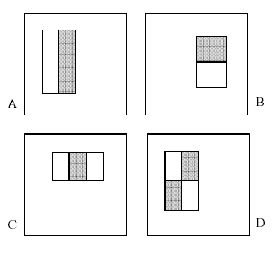
Figure 1: Rectangular features. Example: for A, The value of a two-rectangle feature is the difference between the sums of the pixels within two rectangular regions.

Set minimum rectangular size as 4 by 4 (for example: 4 by 5, 8 by 4, 10 by 11), there are in total nearly 6,000 features.

2. Integral image

Preprocess: normalize each image by dividing each pixel value by the STD of the image.

The value of the integral image at point (x; y) is the sum of all the pixels above and to the left.
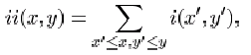
where ii(x; y) is the integral image and i(x; y) is the original image (see Figure 2). Using the following pair of recurrences:
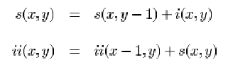
the integral image can be computed in one pass over the original image.

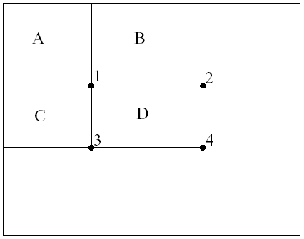

Figure 2: The sum of the pixels within rectangle D can be computed with four array references. The value of the integral image at location 1 is the sum of the pixels in rectangle A. The value at location 2 is A + B, at location 3 is A + C, and at location 4 is A + B + C + D. The sum within D can be computed as 4 + 1 - (2 + 3).

Using the integral image, the rectangular features can be calculated more efficiently.

3. Construction of weak learners

Two suggestions:

- Assume faces and non-faces follow Gaussian distribution, find the threshold with minimum error.

- Exhaustive search for the threshold by discretization of the valid value range.
4. Adaboost algorithm

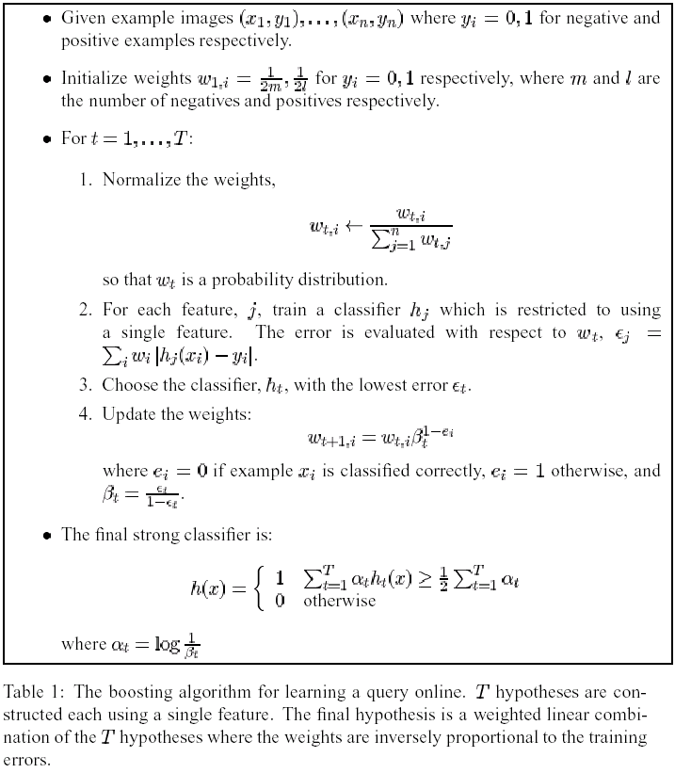

5. Sample Matlab code for reading all bitmap images in a directory
function X = ReadBmps(strDir);
Bmps = dir([strDir '/*.bmp']);
[NBmps, NCols] = size(Bmps);
for i=1:NBmps,
image = double(imread([strDir '/' Bmps(i).name])) / 255;
X(i,:,:) = image;
end

